IBM PROJECT DOCUMENTATION PLASMA DONOR APPLICATION

**TEAM ID - 727819TUCS228**

**TEAM MEMBERS**

SRINITHI K

YUVAPRIYA G

SUTHARSHINI PR

SWATHI A

**CHAPTER 1**

**1. INTRODUCTION**

**1.1 Project overview**

Recent Covid-19 Pandemic has raised alarms over one of the most overlooked areas to focus: Healthcare Management. While healthcare management has various use cases for using data science, patient length of stay is one critical parameter to observe and predict if one wants to improve the efficiency of the healthcare management in a hospital. During the COVID 19 crisis, the requirement of plasma became a high priority and the donor count has become low. Saving the donor information and helping the needy by notifying the current donors list, would be a helping hand. In regard to the problem faced, an application is to be built which would take the donor details, store them and inform them upon a request.

* 1. **Purpose**

This system’s goal is to use an web application to link donors and patients. Patient of this application may post requests for plasma donations or requests . The fundamental solution is to establish a centralized system is that a admin will keep track of current and previous Plasma Donation Events and also keep track of the location of the donor’s plasma using google map.

# CHAPTER 2

# 2. LITERATURE SURVEY

2.**1 Existing Problem**

* + - The already existing model is trained with minimal parameters by leaving the necessary parameter
    - Low accuracy in prediction
    - No feature extraction done
    - High complexity.
  1. **References**

1. Yang J.-J., Li J., Mulder J., Wang Y., Chen S., Wu H., Wang Q., Pan H. Emerginginformation technologies for enhanced healthcare. *Comput. Ind.* 2015;69:3 11.doi:10.1016/j.compind.2015.01.012. [[CrossRef](https://doi.org/10.1016%2Fj.compind.2015.01.012)] [Google Scholar]
2. Cortada J.W., Gordon D., Lenihan B. *The Value of Analytics in Healthcare.* IBM Institute for Business Value; Armonk, NY, USA: 2012. Report No.: GBE03476-USEN-00. [[Google Scholar](https://scholar.google.com/scholar_lookup?title=The%2BValue%2Bof%2BAnalytics%2Bin%2BHealthcare&author=J.W.%2BCortada&author=D.%2BGordon&author=B.%2BLenihan&publication_year=2012)]
3. Center for Medicare and Medicaid Services. [(accessed on 1 August 2017)]; Availableonline:

[https://www.cms.gov/Research-Statistics-Data-and- Systems/Statistics-Trends-](https://www.cms.gov/Research-Statistics-Data-and-%20%20%20%20%20%20Systems/Statistics-Trends-) [andReports](https://www.cms.gov/Research-Statistics-Data-and-Systems/Statistics-Trends-andReports/NationalHealthExpendData/NationalHealthAccountsHistorical.html)

[/NationalHealthExpendData/NationalHealthAccountsHistorical.html](https://www.cms.gov/Research-Statistics-Data-and-Systems/Statistics-Trends-andReports/NationalHealthExpendData/NationalHealthAccountsHistorical.html)

1. Berwick D.M., Hackbarth A.D. Eliminating waste in US health care. *J. Am. Med.*

*Assoc.* 2012;307:1513–1516. doi: 10.1001/jama.2012.362. [[PubMed]](https://pubmed.ncbi.nlm.nih.gov/22419800)

[[CrossRef](https://doi.org/10.1001%2Fjama.2012.362)] [Google Scholar]

1. Makary M.A., Daniel M. Medical error-the third leading cause of death in the US. *Br. Med. J.* 2016;353:i2139. doi: 10.1136/bmj.i2139. [[PubMed](https://pubmed.ncbi.nlm.nih.gov/27143499)] [[CrossRef](https://doi.org/10.1136%2Fbmj.i2139)] [Google Scholar]

Prokosch H.-U., Ganslandt T. Perspectives for medical informatics. *Methods Inf. Med.*2009;48:38–44. doi: 10.3414/ME9132. [[PubMed](https://pubmed.ncbi.nlm.nih.gov/19151882)] [[CrossRef](https://doi.org/10.3414%2FME9132)] [Google Scholar]

1. Simpao A.F., Ahumada L.M., Gálvez J.A., Rehman M.A. A review of analytics andclinical informatics in health care. *J. Med. Syst.* 2014;38:45. doi:

10.1007/s10916-014-0045-x. [[PubMed](https://pubmed.ncbi.nlm.nih.gov/24696396)] [[CrossRef](https://doi.org/10.1007%2Fs10916-014-0045-x)] [Google Scholar]

1. Ghassemi M., Celi L.A., Stone D.J. State of the art review: The data revolution incritical care. *Crit. Care.* 2015;19:118. doi: 10.1186/s13054- 015-0801-4. [[PMC free article](https://www.ncbi.nlm.nih.gov/pmc/articles/PMC4361206/)] [[PubMed](https://pubmed.ncbi.nlm.nih.gov/25886756)] [[CrossRef](https://doi.org/10.1186%2Fs13054-015-0801-4)] [Google Scholar]
2. Tomar D., Agarwal S. A survey on Data Mining approaches for Healthcare.

*Int. J.*

*Bio-Sci. Bio-Technol.* 2013;5:241–266. doi: 10.14257/ijbsbt.2013.5.5.25. [[CrossRef]](https://doi.org/10.14257%2Fijbsbt.2013.5.5.25) [Google Scholar]

1. Panagiota Galetsia , Korina Katsaliakia , Sameer Kumarb,⁎ a School of Economics, Business Administration & Legal Studies, International Hellenic University, 14th km

Thessaloniki-N. Moudania, Thessaloniki, 57001, Greece b Opus College of Business,University of St. Thomas Minneapolis Campus, 1000 LaSalle Avenue, Schulze Hall 435,

Minneapolis, MN 55403, USA

# Problem Statement Definition

Many major medical conditions are treated by plasma. One of the most well-known techniques known as plasma treatment, plasma is used to cure various incurable diseases. As there were no vaccines available to treat the infected patients during the Covid-19 emergency, the need for plasma increased dramatically. Plasma therapy had a high probability of recovery but a very low donor count, therefore it was crucial to learn more about the donors in these circumstances. It would be helpful to save the contributor information and let clients know about the recurring donors because it can help them find the crucial information more quickly.

**CHAPTER 3**

# IDEATION AND PROPOSED SOLUTION

* 1. **Empathy Map Canvas**

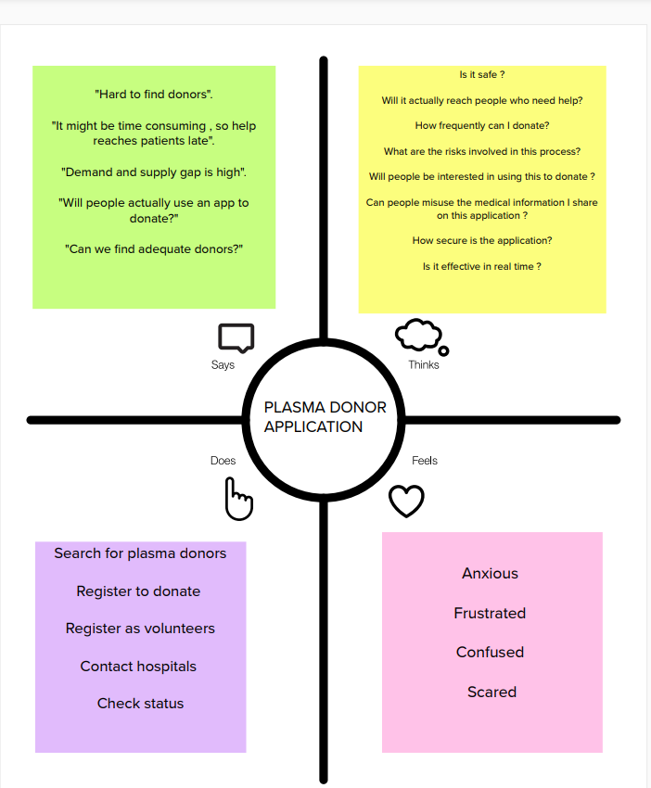

# Ideation & Brainstorming

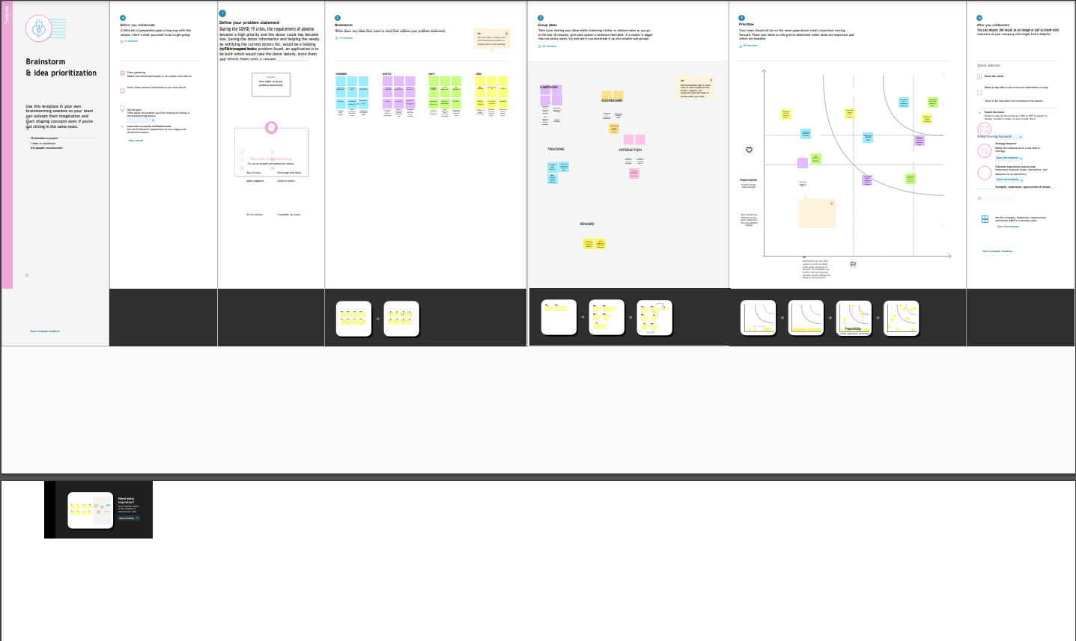

* 1. **Proposed Solution**

The length of the stay can be predicted using either Random forest or Decision Tree for more accuracy. Certain parameters like age, stage of the diseases, disease diagnosis, severity of illness, type of admission, facilities allocated, etc., are used for prediction. IBM Cognos will be used for data analytic s. The model will be trained using colab. It predicts the length of stay (LOS) of the patients with more accuracy. As a result proper resources and therapy can be provided . Patients can get proper treatment and better medical care than before which helps them for their faster recovery. So the prediction minimizes the overflow of patients and helps in resource management and optimize their resource utilization. Hence this leads to faster recovery and lower the expenses for treatment. It improves the trust in hospital management. It avoids the major risk of spreading infection among the hospital staff. This leads to overall safety of hospital staff and patients. Resource consumption is optimized. This model can be used by all government hospitals, private hospitals, and even in the model is trained with the real world hospital survey for better prediction small clinics. Length of the stay will be predicted with more accuracy. This model predicts the length of the stay for all kinds of patients and predicts with more accuracy.

# Problem Solution fit

# 

**CHAPTER 4**

**REQUIREMENT ANALYSIS**

* 1. **Functional requirement**

**FUNCTIONAL REQUIREMENTS:**

Following are the functional requirements of the proposed solution.

|  |  |  |
| --- | --- | --- |
| **FRNo.** | **FunctionalRequirement(Epic)** | **SubRequirement(Story/Sub-Task)** |
| FR-1 | User Registration | Registration through Form(WebApp) |
| FR-2 | User Confirmation | Confirmation via Email |
| FR-3 | Certification | After the donor donates plasma, we will give them a certificate of appreciation and authentication. |
| FR-4 | Statistical data | The availability of plasma is given in the page as stats,which will be helpful for the users. |
| FR-5 | User Plasma Request | Users can request to donate plasma by filling out the request form on the page. |
| FR-6 | Searching/reporting requirements | Users can use the search bar to lookup information about camps and other topics. |

* 1. **Non-Functional requirements**

|  |  |  |
| --- | --- | --- |
| NFR-4 | **Performance** | Users should have a proper Internet Connection. |
| NFR-5 | **Availability** | The system including the online and offline components should be available 24/7. |
| NFR-6 | **Scalability** | The application has the ability to handle growing number of users and load without compromising on  Performance and causing disruptions to user experience. |

**CHAPTER 5**

# PROJECT DESIGN

* 1. **Data Flow Diagrams**

A data flow diagram is a traditional visual representation of the information flows within a system. A neat and clear DFD can depict the right amount of the system requirement graphically.it shows how data enters and leaves the system, what changes the information and, where data is stored

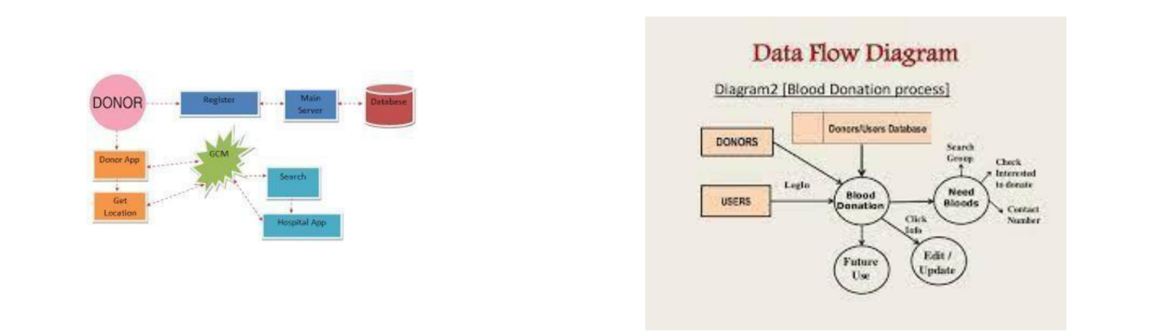

* 1. **Solution & Technical Architecture**

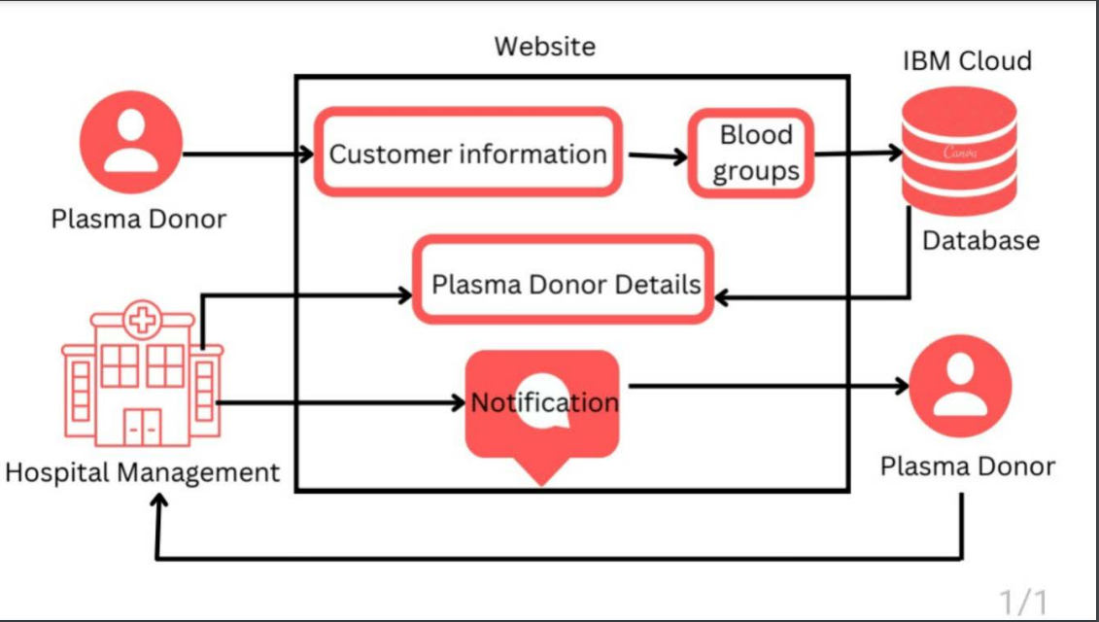

* 1. **USER STORIES**

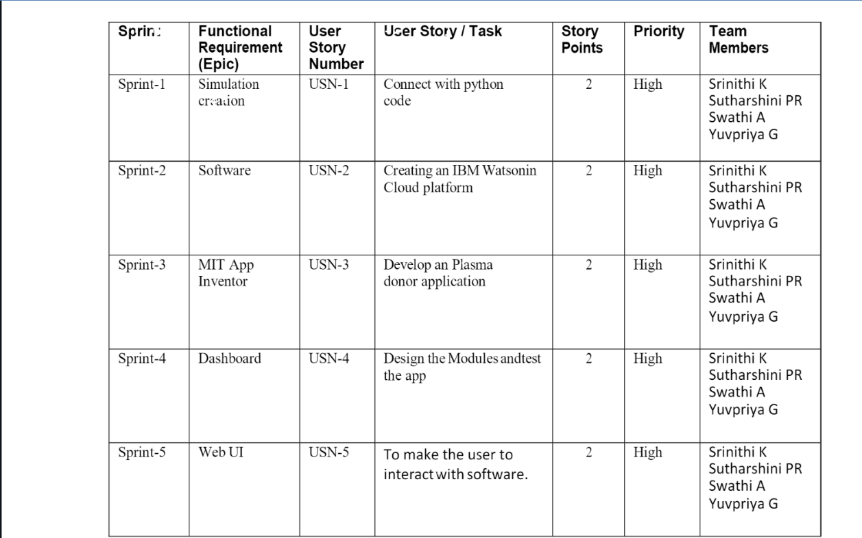

**CHAPTER 6**

# PROJECT PLANNING

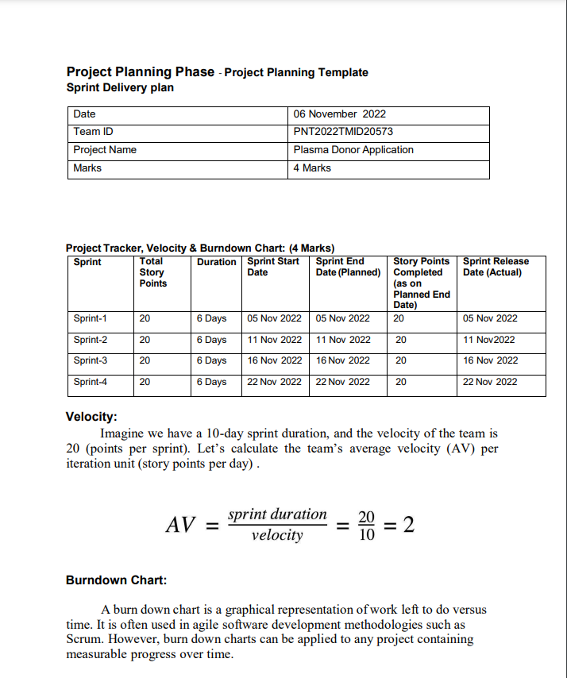

* 1. **Reports from JIRA**

# Burnt Up Chart

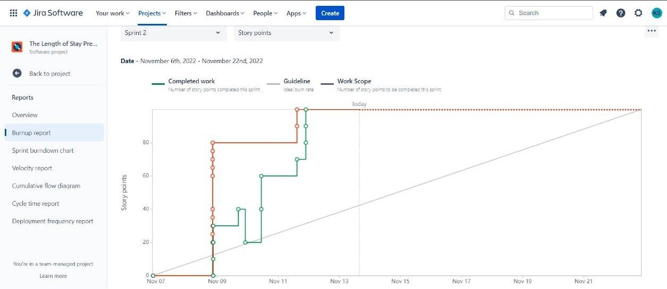

**Burnt Down Chart**

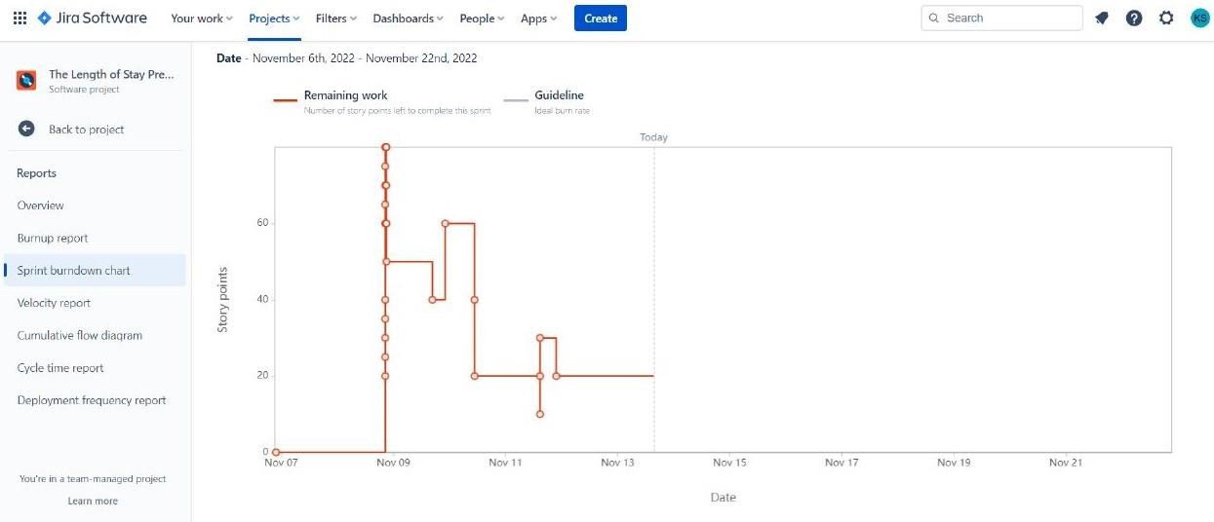

# 7.CODING & SOLUTIONING (Explain the features added in the project along with code)

* 1. **Feature 1**

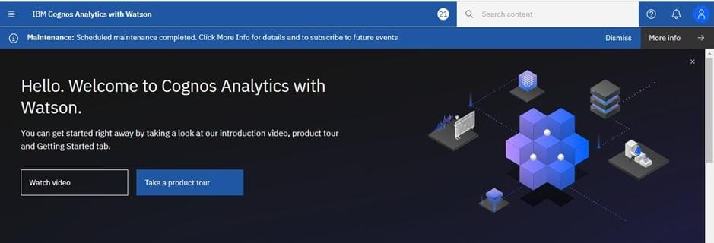

# RESULTS

* + 1. **Performance Metrics**

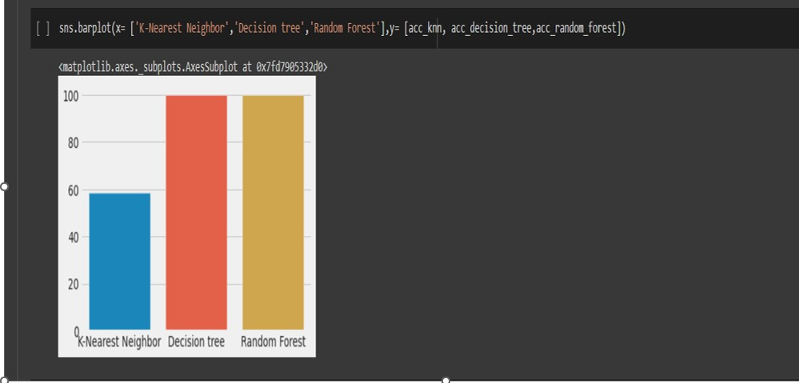

**CHAPTER 8**

# ADVANTAGES & DISADVANTAGES Advantages

* Analyzing clinical data to improve medical research
* Using patient data to improve health outcomes
* Gaining operational insights from healthcare provider data
* Improved staffing through health business management analytics
* Research and prediction of disease.
* Automation of hospital administrative processes.
* Early detection of disease.
* Prevention of unnecessary doctor's visits.
* Discovery of new drugs.
* More accurate calculation of health insurance rates.
* More effective sharing of patient data.

# Disadvantages

## **Replacing Medical Personnel**

Application of technology in every sphere of human life is improving the way things are done. These technologies are are also posing some threat to world of works. Robotics are replacing human labor.

## **Data Safety**

Data security is another challenge in applying big data in healthcare. Big data storage is usually targets of hackers. This endangers the safety of medical data. Healthcare organisations are very much concerned about the safety of patients' sensitive personal data. For this, all healthcare applications must meet the requirement for data security and be HIPAA compliant before they can be deployed for healthcare service.

# 

# CHAPTER 9

# CONCLUSION

# Analytics is the science of analyzing raw datasets in order to derive conclusion regarding the information they hold. It enables us to discover patterns in the raw data and draw valuable information from them. To some, the domain of healthcare data analytics may look new, but it has a lot of potential, especially if you wish to engage in challenging job roles and build a strong data analytics profile in the upcoming years. In this blog, we have covered some of the major topics such as what is healthcare data analytics, its applications, scope, and benefits, etc. We hope it helps you in your decision- making as a healthcare data analytics professional.

# CHAPTER 10

# FUTURE SCOPE

The Future of Healthcare, Intel provides a foundation for big data platforms and AI to advance health analytics. Predictive data analytics is helping health organizations enhance patient care, improve outcomes, and reduce costs by anticipating when, where, and how care should be provided. The future of big data in healthcare will be determined by technological breakthroughs from 2022 to 2030.

Complete patient care and cost-effective prescription procedures are required for population health management. To assess clinical and claims data, they must be combined on the same platform.

Countries around the world have started to invest more capital in medical infrastructure, pharmaceuticals, and healthcare smart analytics solutions. The market is growing and will continue to expand, given the benefits of healthcare data analytics. It has also risen as a good career option for fresh data science and data analytics graduates or professionals who wish to build their career in the healthcare sector. Due to the sensitivity of the profession, the salary offers for healthcare data analysts are lucrative around the world.

Apart from the remuneration, the opportunities to work with some of the biggest names in the healthcare sector is also worth mentioning. Hence, healthcare data analytics is growing to be one of the most rewarding branches of data analytics in the coming future.

# APPENDIX

Source Code

